LD Awareness Month - October 2020
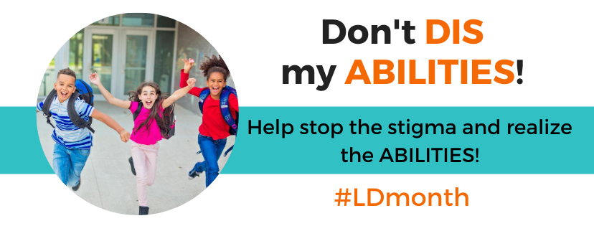
Throughout October, Learning Disabilities Awareness month, the Learning Disabilities Associations of Ontario will be raising awareness to reduce stigma to allow people to get the supports they need to reach their potential.
“In the middle of this Pandemic it is clear that those who already faced barriers to success now have additional challenges to overcome” states Lawrence Barns, President & Chief Executive Officer of LDAO. “This Pandemic has heightened challenges at school, university, the workplace and of course homes in lockdown. Our desire is to remind people that stigma has very real negative consequences and that support has the reverse impact. Statistics in Canada weren’t great and likely worse during this time, its time for all of us to do better at supporting those with Learning Disabilities”
The Stats
- 1 In 10 people in Ontario are impacted.
- 35% of students with LDs drop out of school
- 62% of students with LDs will be unemployed a year after graduation
- 36% of youth in correctional facilities have specific learning disabilities.
- Almost 50% of adolescent suicides have a diagnosis of an LD. (Source LDAC survey)
Together we can change this!
If society helps individuals with Learning Disabilities to succeed, all of the above statistics can be radically altered, leading to successful lives that can impact our communities for the better and people with learning disabilities can become among the most creative, and productive members of our communities.
About the Campaign:
The greatest hurdle a person with an LD often has to overcome is the stigma and public perception, labelled lazy, stupid or incompetent they begin to hide their disability and instead struggle in silence. Yet with their strengths, and above average intelligence, some simple support can see them excel in their chosen field. Our hope is to see Ontario as the leader in destroying the barriers stigma creates.
About Us:
The Learning Disabilities Associations of Ontario are registered charities dedicated to improving the lives of children, youth and adults with learning disabilities. Through the local chapter The LDA OF (insert as required) services to the public are provided through a network of Chapters across Ontario. LDAs receive no government funding for their work and rely on the generous support of donors and funders.
Our Mission:
LDAO’s mission is to provide leadership in learning disabilities advocacy, research, education and services and to advance the full participation of children, youth and adults with learning disabilities in today’s society. We value promoting positive change through:
- Innovation
- Strategic partnerships
- Credible advocacy
- Informed public policy and
- Quality products and services
More about Learning Disabilities:
- By definition someone with LDs has average to above average intelligence
- LDs impact certain skills, most of which can be improved with the right supports.
- Because LDs usually exhibit in the school system, those with LDs can be identified early in life, and early intervention improves confidence.
- When they don’t receive appropriate support, individuals with LDs have higher than the average rates of school dropout, unemployment and poverty.
- LDs can be inherited and many parents are now finding they are have been impacted in their lives as their children are diagnosed.
Dyslexia: Difficulties with oral and/or written language, i.e., listening, speaking, reading, and writing.
Dysgraphia: Difficulties with writing legibly with age-appropriate speed, and with written expression
Dyscalculia: Difficulties with basic math skills, calculating, and math problem-solving
Executive Function: A set of mental processes that helps connect past experience with present action. People use it to perform activities such as planning, organizing, strategizing, paying attention to and remembering details, and managing time and space.
For Further Information Contact your local LDA chapter: www.LDAO.ca/contact-us/ldao-chapters/

