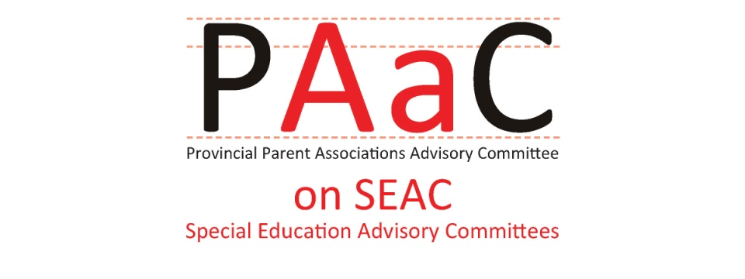

PAAC on SEAC Effective Practices Handbook for SEAC Members

Examples of Effective Practices for Review of Special Education Plans and Special Education Budgets

Review of Special Education Plans:
Effective Practices to support SEAC participation in review of special education programs and services include:
- Planning regular presentations to SEAC about special education programs and services, the needs of exceptional students, and the latest research on effective interventions.
- Allowing time on each SEAC agenda for a short presentation, or discussion, on specific exceptionalities or special education programs and services.
- Inviting SEAC members to participate in working groups and sub-committees involved in program reviews, or new initiatives.

Directives from the Ministry of Education, regarding the Special Education Report, strongly encourage the school board to make the Special Education Plan accessible to the public in user-friendly format, on their public website.
Effective Practices to ensure the Special Education Plan/Report is accessible and easy to understand include:
- Reviewing key documents, including the Standards for Special Education Plans (2000) and the components included in the annual Special Education Report Checklist, to determine what information is to be included in the Special Education Report.
- Reviewing each section of the Special Education Plan to make sure that it is easy to understand and written in a user friendly style.
- Providing suggestions as to how the information can be made accessible to parents, students and the general public.
- Providing the complete Special Education Plan on the school board website; providing printed copies at key locations, including school libraries, school offices, information displays and parent resource centers; and, developing a flyer or handout for parents.

Public consultation is a key part of the Special Education Plan Review and SEAC also has an important role in public consultations about special education and changes in programs and services.
Effective practices to enhance parent engagement in special education include:
- Inviting Parent Involvement Committee (PIC) members and members of School Councils to public consultations about special education.
- Making presentations to PIC members on an annual or regular basis about SEAC, special education and annual planning for special education programs and services.
- Requesting PIC members, and School Council Chairs, to share important information about SEAC or special education with families.

Review of Special Education Budget
Under Regulation 464/97, SEAC members are to have the opportunity to participate in the special education budget planning process. Each school board has a different process for the development of budgets, often including the establishment of a Budget committee or ad hoc group. PAAC on SEAC recommends that SEAC members be kept informed of the budget process and timelines.

Effective Practices to support SEAC participation in budget planning for special education programs and services include:
- Providing SEAC members with orientation and training regarding financial statements, the Special Education Grant, revenues and expenditures
- Providing timely information on the Special Education Grant each year when Ministry of Education releases the grant regulations
- Inviting SEAC members to participate in Budget Committee or working groups
- Providing regular updates on Financial Statements and the budget process at SEAC meetings
- Relating special education budget information to statistical information about students provided in October Reports of Numbers of Elementary and Secondary Students, and to numbers of staff assigned annually to special education roles
- Planning a SEAC presentation to Trustees as part of public consultation on the annual school board budget.

