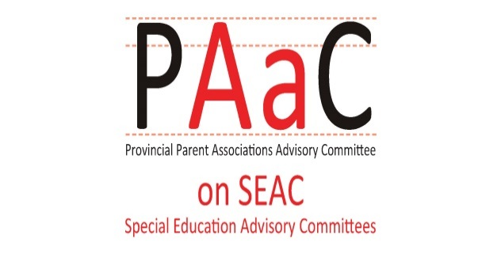

PAAC on SEAC Survey
2019-20
The Provincial Parent Association Advisory Committee on Special Education Advisory Committees (PAAC on SEAC) conducted surveys of SEAC members across Ontario in 2009 and again in 2014, to look at SEAC membership, practices and training needs. PAAC on SEAC Survey 2014: Executive Summary & PAAC on SEAC Response.
PAAC on SEAC is now distributing a new version of the survey, with comparable questions, to find out what has changed and whether there are new issues or challenges. After analyzing the results, we will post the results on the PAAC on SEAC Website at: www.paac-seac.ca and will share our report with the Ministry of Education.
All information collected will be held in the strictest of confidence. Upon closing the survey, the information will be calculated and compiled into a report. This information will inform PAAC on SEAC members about the effectiveness of SEACs across the province.
The survey should take roughly 10 to 15 minutes to complete and individual surveys should be submitted by January 31, 2020. In the past, some SEACs have addressed the questions in a SEAC meeting and submitted a group response, in addition to having individual SEAC members respond.
The survey is available at www.surveymonkey.com/r/HYZ3PWY

