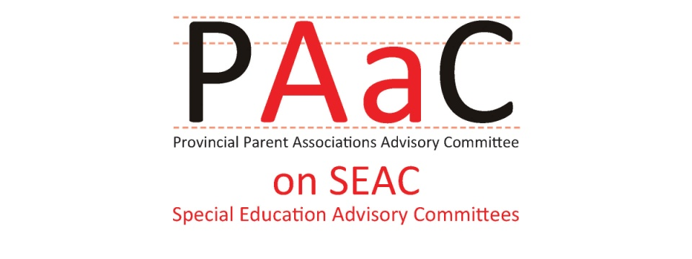

PAAC on SEAC
Supporting Effective SEACs
November 2013

PAAC on SEAC is the only group in Ontario that brings together provincial parent associations to communicate and co-operate on issues pertaining to Special Education Advisory Committees (SEAC). Currently PAAC ON SEAC members support over 300 SEAC members in 58 different school boards in Ontario.

PAAC on SEAC has been supporting SEAC members for 30 years through regular meetings of representatives from provincial associations. PAAC on SEAC has an assigned liaison with the Ministry of Education who attends 3 to 4 PAAC on SEAC meetings each year. In addition, PAAC on SEAC is able to participate in government consultations on key issues that impact students with special needs. Consultations may occur in person at meetings, through submissions or by having representatives of PAAC on SEAC attend provincial consultation sessions.

PAAC on SEAC provides information to SEAC members through the provincial associations, sharing key documents or announcements. PAAC on SEAC has also developed resources for SEACs including the Handbook for Members of Special Education Advisory Committees (1985, 1995, updated in 2002) and the PAAC on SEAC Effective Practces Handbook for SEAC Members (2009). PAAC on SEAC produces an Annual Calendar for SEACs that provides an annual timetable for SEAC activities that supports the setting of annual goals, and timely examination of the Special Education Plan and Budget.

Many of the PAAC on SEAC member associations also have strong individual relationships with the Ministry of Education that have resulted in initiatives to enhance teacher capacity, support parent engagement and success for students with special education needs.

PAAC on SEAC is in a unique position to identify issues and trends as reported by volunteer SEAC members, many of whom are parents. PAAC on SEAC has concerns about the lack of accountability in special education and the inconsistency from one board to another in the provision of special education programs and services.

Background:
Role and responsibilities of Special Education Advisory Committees (SEAC) are defined by Regulation 464/97. The regulation defines the membership which can include up to 12 local association representatives (Section 2.2) where a local association is defined as:
“local association” means an association or organization of parents that operates locally within the area of jurisdiction of a board and that is affiliated with an association or organization that is not an association or organization of professional educators but that is incorporated and operates throughout Ontario to further the interests and well-being of one or more groups of exceptional children or adults. O. Reg. 464/97, s. 1.”

The members of PAAC on SEAC are provincial organizations that are eligible to have local association members nominated to be members of SEAC and their alternates. All members of SEAC, except Trustees, are volunteers and many are parents of children with special education needs. Parent volunteers have been a significant part of SEACs for over 30 years.

The majority of SEACs operate successfully and all members work collaboratively in the best interests of students with special education needs.

PAAC on SEAC Concerns:

- SEAC members’ ability to fulfill their legally mandated role to participate in:
  - Review and development of the annual Special Education Report
  - Review and development of the annual Special Education Budget
  - Development of Policies and Procedures that impact students with special education needs
  - Be heard by the Board of Trustees

- SEAC members have expressed concern about the lack of meaningful consultation on special education programs and services as evidenced by Minority Reports from several SEACs in 2013. The Minority Reports identify concerns with the timing and involvement of SEAC members in the review of the Special Education Plan.
- SEACs have difficulty accessing, or have been denied access to the ONSys “October Report” data that School Boards must submit to the Ministry. This data regarding student Identification and Placements, numbers of non-identified students with IEPs, etc. is essential to enable SEACs fulfill their mandated role.
- SEACs have expressed concern about the special education budget development process and have not been provided sufficient information pertaining to Budget-setting

Solution: The Ministry could foster the sharing of effective SEAC practices and provide a reminder about the mandatory requirements of SEAC. The new SEAC webpages on the Ministry of Education website is a great start.

- PAAC is concerned about the use of blocker shields and other types of safety equipment in some boards, and about how SEAC might promote evidence-based and effective practices.
- Community agencies and SEAC members have expressed concerns about the use of blocker shields and the need for policies and procedures that reflect evidence based practices for behavior management and ensure parent involvement in decisions affecting students.

Solution: A Ministry policy or guidelines regarding use of safety equipment would assist school boards in developing evidence based policies and procedures. The new mental health initiatives are providing more resources for school boards; however, there has not been a focus on students with special education needs.

- Challenges of Recruiting and Retaining SEAC members:
  - SEAC members are excellent examples of parent engagement in education as most volunteers commit to at least one 4 year term, attend 10 meetings per year and are active on SEAC sub-committees. SEAC plays an important role in fostering parent engagement in special education by reviewing special education resources, including the Parent Guides and website materials to make sure they are easy to read and support parent participation in the identification, Placement and Review Committee (IPRC) and the Individual Education Plan (IEP).
  - Finding volunteers willing and able to commit to four years as a SEAC member is challenging, especially in rural and northern areas. SEAC members who are frustrated with the lack of meaningful consultation are less likely to continue for another term on SEAC.
  - Where communication between SEAC and Administration and/or trustees has floundered, some SEAC reps have felt personally threatened by the conflicts that remained unresolved. This discourages the involvement of parents and parent associations, and makes it far less likely to find SEAC reps.

Solution: PAAC on SEAC is interested in working with the Ministry to increase awareness of SEAC and the valuable contribution made by volunteers to special education.

4. Utilize the assistance of PAAC on SEAC:

PAAC is the only group in Ontario that brings together provincial parent associations to communicate and co-operate on issues pertaining to Special Education Advisory Committees.
  - By increasing the membership of more provincial associations as members, PAAC has been strengthening its extensive communication network.
  - Through our member associations, PAAC can quickly and efficiently reach SEAC reps in a majority of the province’s school boards.
  - Provincial parent associations are valuable resources not only to each other and to SEACs but also to the Ministry of Education, school board officials, service providers, parents and the community at large.

Solution: Ensure that PAAC on SEAC receives all SEAC-related communication from the Ministry and all updates, memos, updates and invitations related to special education policies and programs that are sent to SEACs

PAAC on SEAC recognizes that the majority of SEACs are working successfully. Many SEACs have adapted the effective practices endorsed by PAAC on SEAC in the 2009 Handbook. SEAC members are dedicated volunteers who bring personal experience and specialized knowledge to the committees. The contribution made by SEAC members is valuable and their advice has contributed to improvements in special education programs and services.

Co-Chairs of PAAC on SEAC:
Alison Morse and Katie Muirhead

