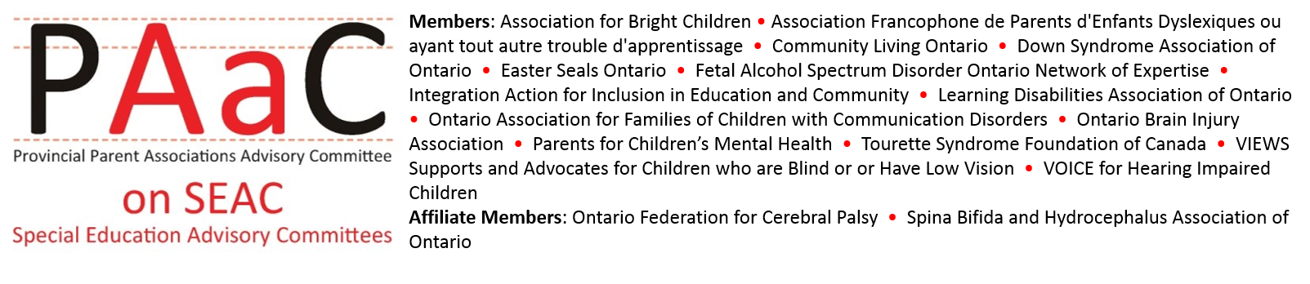

NEW SEAC training resources available!
PAAC on SEAC members are pleased to announce the launch of updated and new training materials for SEACs. These training materials were developed to address the growing need for resources to support SEAC members and were made possible by a Ministry of Education Parent Reaching Out Grant.
The PAAC on SEAC Effective Practices Handbook for SEAC Members, originally developed in 2010, has been updated. The Handbook provides examples of effective practices that can improve the effectiveness of SEAC and help SEAC members understand their role and responsibilities. The Handbook is available in both English and French.
We have also developed 3 brand new Video Training Modules to help support SEAC training, orientation, and to improve your SEAC effectiveness. Click on the images below to view each new module.
Purpose of SEAC  SEACs play an important role in your school board. Learn what a SEAC does and how they contribute to special education. | Roles and Responsibilities  What exactly does a SEAC member do? Learn how to be an effective member of your SEAC. | Meeting Process  Setting agendas, making motions, minority reports and much more. How to be a part of a successful SEAC meeting.

