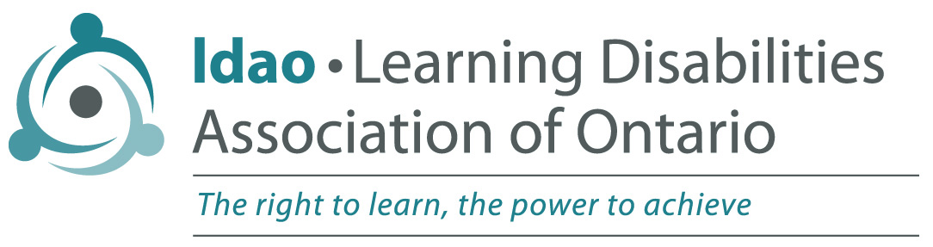

Accessible Customer Service Policy

Adopted by LDAO Board of Directors March 5, 2012

The Learning Disabilities Association of Ontario is committed to excellence in serving all customers including people with disabilities.

Assistive devices
We will ensure that our staff/volunteers who deal with the public are familiar with various assistive devices that may be used by customers with disabilities while accessing our goods or services.

Communication
We will communicate with people with disabilities in ways that take into account their disability.

Service animals
We welcome people with disabilities and their service animals. Service animals are allowed on the parts of our premises that are open to the public.

Support persons
A person with a disability who is accompanied by a support person will be allowed to have that person accompany them on our premises and in our programs. Fees will not be charged for support persons (except for any meals involved).

Notice of temporary disruption
In the event of a planned or unexpected disruption to services or facilities for customers with disabilities (programs, support groups, public meetings) LDAO chapters will notify customers promptly. This clearly posted notice will include information about the reason for the disruption, its anticipated length of time, and a description of alternative facilities or services, if available. Notice will be placed on the chapter website and delivered by e-mail or phone to registered participants.

Customer Service Training
LDAO will provide training to staff /volunteers who interact with the public in resource facilitating, programs, support groups or public meetings. This training will be provided to new staff within three months after hiring.

Training will include:
- An overview of the Accessibility for Ontarians with Disabilities Act, 2005 and the requirements of the customer service standard
- LDAO’s policy related to the customer service standard.
- How to interact and communicate with people with various types of disabilities
- How to interact with people with disabilities who use an assistive device or require the assistance of a service animal or a support person
- What to do if a person with a disability is having difficulty in accessing an LDAO chapter’s programs.

Feedback process
Customers who wish to provide feedback on the way an LDAO chapter provides goods and services to people with disabilities can contact the chapter by e-mail or phone. All feedback will be directed to the chapter president and customers can expect to hear back within 10 business days.
Complaints will be addressed according to our organization’s regular complaint management procedures.

Modifications to this or other policies
Any policy of the Learning Disabilities Association of Ontario that does not respect and promote the dignity and independence of people with disabilities will be modified or removed.

